Market Making
Bid/Ask Quoting, Inventory Risk, Adverse Selection & the Avellaneda-Stoikov Model
Earning the Spread Without Betting on Direction
A Level 5 module in the Quantitative Finance Curriculum
Covers: Bid/ask quoting · inventory management · spread capture · adverse selection · order-book imbalance · queue position · fill probability · inventory risk · reservation price · Avellaneda-Stoikov model · dynamic spreads · hedging · cross-venue market making

Table of Contents
How to Use This Guide
What You Need to Know Before Starting
Understand Before Proceeding
Why It Matters
How This Connects to the Rest of the Curriculum
Glossary of Recurring Terms
Part 1 — Quoting, Spread Capture & the Market Maker's P&L
1.1 What a Market Maker Actually Earns
1.2 The Two Structural Risks: Inventory and Adverse Selection
Part 2 — Inventory Risk and the Reservation Price
2.1 Why Symmetric Quoting Fails
2.2 The Reservation Price
2.3 The Avellaneda-Stoikov Model
Part 3 — Adverse Selection
3.1 Being Filled for the Wrong Reason
3.2 Measuring Order-Flow Toxicity
3.3 Order-Book Imbalance and Short-Term Prediction
Part 4 — Queue Position and Fill Probability
4.1 Why Queue Position Is a First-Class Variable
4.2 Modelling Fill Probability
Part 5 — Dynamic Spreads, Hedging & Cross-Venue Market Making
5.1 Dynamic Spread Rules
5.2 Hedging Residual Inventory
5.3 Cross-Venue and Multi-Asset Market Making
Part 6 — Options Market Making: Greeks-Based Risk
6.1 Delta-Hedging as Continuous Inventory Management
6.2 Gamma and Vega as the Residual Risk
Practical Exercise
Common Beginner Mistakes
Advanced Extensions
Professional Applications
Where to Go Next

How to Use This Guide
This Level 5 module treats market making as a distinct discipline, not a variant of directional alpha research. It assumes the microstructure, stochastic mathematics, and derivatives-hedging prerequisites below are already solid, and moves quickly and densely from there — deriving the Avellaneda-Stoikov quoting model, the mechanics of adverse selection, and the queue-position and fill-probability machinery that separates a working market-making system from a naive symmetric-quote strategy that quietly bleeds money.

What You Need to Know Before Starting
- Market Microstructure (Level 2, Depth 3+) — order-book mechanics, priority rules, and tick structure at real depth, not an introductory level.
- Stochastic Mathematics — Brownian motion, Itô's lemma, and stochastic optimal control, needed to follow the Avellaneda-Stoikov derivation in Section 2.3.
- Derivatives — needed for Section 5.2's hedging mechanics, where residual inventory is offset using futures or options.

Understand Before Proceeding
Prerequisite gate —
Do not attempt market-making strategy design before market microstructure is Depth 3+ and you can explain adverse selection precisely. A market maker who cannot articulate why a fill is informative — not just that it happened — will misprice every quote in the book. This is the single most common reason naive market-making strategies fail: not bad execution technology, but a design that never accounted for who is on the other side of the trade.

Why It Matters
Market making is a distinct discipline from directional alpha research — profitability comes from managing inventory and adverse selection, not from predicting direction. A market maker who is right about direction more than 50% of the time is, in a sense, doing it wrong: the entire business model is designed to be approximately direction-agnostic, earning the bid-ask spread on turnover while actively managing the two risks (inventory, adverse selection) that determine whether that spread capture survives contact with real order flow.

How This Connects to the Rest of the Curriculum
- Research — Calibrating fill-probability and adverse-selection models from historical order-book data is applied microstructure research — the empirical counterpart to the theoretical machinery in Parts 3–4.
- Development — Requires very low-latency quoting/cancelling infrastructure and real-time inventory tracking; the models in this module are only as good as the systems that can act on their output in microseconds.
- Trading — A distinct trading discipline with its own risk metrics (inventory risk, spread capture) separate from directional P&L, run on its own book with its own limits.

Glossary of Recurring Terms
Spread capture — The P&L earned from repeatedly buying at the bid and selling at the ask (or vice versa), before accounting for inventory and adverse-selection costs.
Inventory risk — The risk that a market maker's accumulated net position (long or short) loses value due to an adverse price move before it can be unwound.
Adverse selection — The tendency for a market maker's resting orders to be filled disproportionately by counterparties with superior short-term information, so fills cluster right before unfavorable price moves.
Reservation price — The price at which a market maker with a given inventory is indifferent between holding and trading further — the Avellaneda-Stoikov model's central construct, shifted away from the mid-price by current inventory.
Avellaneda-Stoikov (A-S) model — A stochastic optimal control framework (2008) that derives optimal bid/ask quotes as a function of inventory, volatility, time horizon, and risk aversion, by skewing quotes around a reservation price rather than the raw mid-price.
Order-book imbalance — The normalized difference between resting bid and ask volume at the top of the book, one of the most robust short-horizon predictors of the next mid-price move.
Queue position — An order's position within the FIFO (or pro-rata) queue of resting orders at a given price level, which directly determines its fill probability and time-to-fill independent of price.
Fill probability — The probability that a resting limit order is executed within a given time horizon, typically modelled as decaying with distance from the best quote and with queue position.
Order-flow toxicity — A measure (e.g. VPIN) of how informationally imbalanced recent trading activity has been — high toxicity signals a higher probability that resting orders are about to be adversely selected.
Dynamic spread — A quoting rule that widens or narrows the bid-ask spread in real time based on volatility, inventory, and order-flow toxicity, rather than quoting a fixed spread regardless of conditions.
Cross-venue market making — Quoting the same or correlated instruments across multiple trading venues simultaneously, requiring inventory from all venues to be netted and hedged centrally rather than venue by venue.
Delta / gamma / vega / theta — The standard options Greeks: delta (sensitivity to the underlying's price), gamma (sensitivity of delta itself to the underlying's price), vega (sensitivity to implied volatility), and theta (sensitivity to time decay) — the risk surface an options market maker manages beyond simple inventory.

Part 1 — Quoting, Spread Capture & the Market Maker's P&L

1.1 What a Market Maker Actually Earns
A market maker continuously posts both a bid and an ask, profiting from the spread between them whenever both sides are filled. Gross P&L per round trip is simply the quoted spread times size; the entire discipline is about the two forces that erode that gross number before it becomes realised profit.
P&L = Spread Capture − Inventory Risk Cost − Adverse Selection Cost
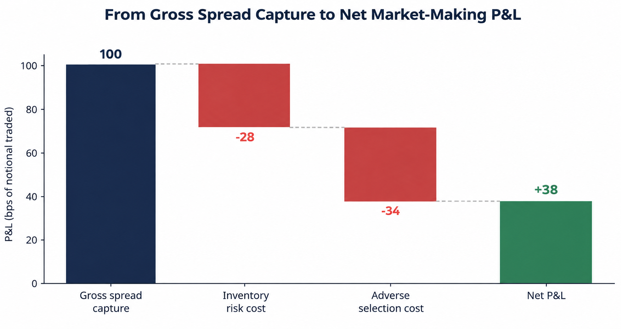
Figure 1.1 — Illustrative P&L decomposition: gross spread capture is eroded first by inventory risk cost, then by adverse selection cost, leaving a materially smaller net P&L. The two cost terms — not the quoted spread itself — are what separates a profitable market maker from an unprofitable one running the same nominal spread.
This decomposition is the reason a market maker cannot simply judge performance from gross turnover or quoted spread width. Two desks quoting an identical 4bps spread on the same instrument can produce very different net outcomes purely based on how well each manages the inventory and adverse-selection terms — which is precisely the subject of Parts 2 and 3.

1.2 The Two Structural Risks: Inventory and Adverse Selection
Inventory risk arises because fills on the bid and ask rarely arrive in perfectly matched pairs — a market maker accumulates a net long or short position between fills, exposed to whatever the price does next (Part 2). Adverse selection arises because the market maker cannot see who is on the other side of each fill — some incoming orders carry short-term information the market maker does not have, and those are disproportionately the ones that get filled against a mispriced quote (Part 3). Both risks exist even in a perfectly liquid, low-latency system; they are structural to the act of quoting, not an execution-quality problem to be engineered away.

Part 2 — Inventory Risk and the Reservation Price

2.1 Why Symmetric Quoting Fails
A naive strategy quotes a fixed spread symmetrically around the mid-price regardless of current inventory. This has no mechanism to correct an accumulating position: if order flow is even mildly imbalanced, inventory random-walks away from zero, and the market maker ends up carrying a directional bet — exactly what the business model is supposed to avoid — sized by whatever the market handed it rather than by design.
Common beginner mistake —
Quoting symmetric spreads regardless of inventory, allowing inventory risk to accumulate unmanaged. The fix is not a wider spread — it is skewing the quotes themselves based on current inventory, which is precisely what the reservation price below formalizes.

2.2 The Reservation Price
The reservation price (or indifference price) is the price at which a market maker holding inventory q is exactly indifferent between their current position and being flat. Rather than quoting symmetrically around the mid-price s, quotes are centered around this shifted reservation price:
r(s,q,t) = s − q·γ·σ²·(T−t)
where q is current inventory, γ is the market maker's risk aversion, σ² is return variance, and (T−t) is the remaining time horizon. When long (q>0), the reservation price sits below the mid-price, making the market maker relatively more eager to sell than buy; when short (q<0), it sits above mid, encouraging buying. This is a self-correcting mechanism: the more inventory accumulates, the harder the model pulls quotes to trade it back toward flat.
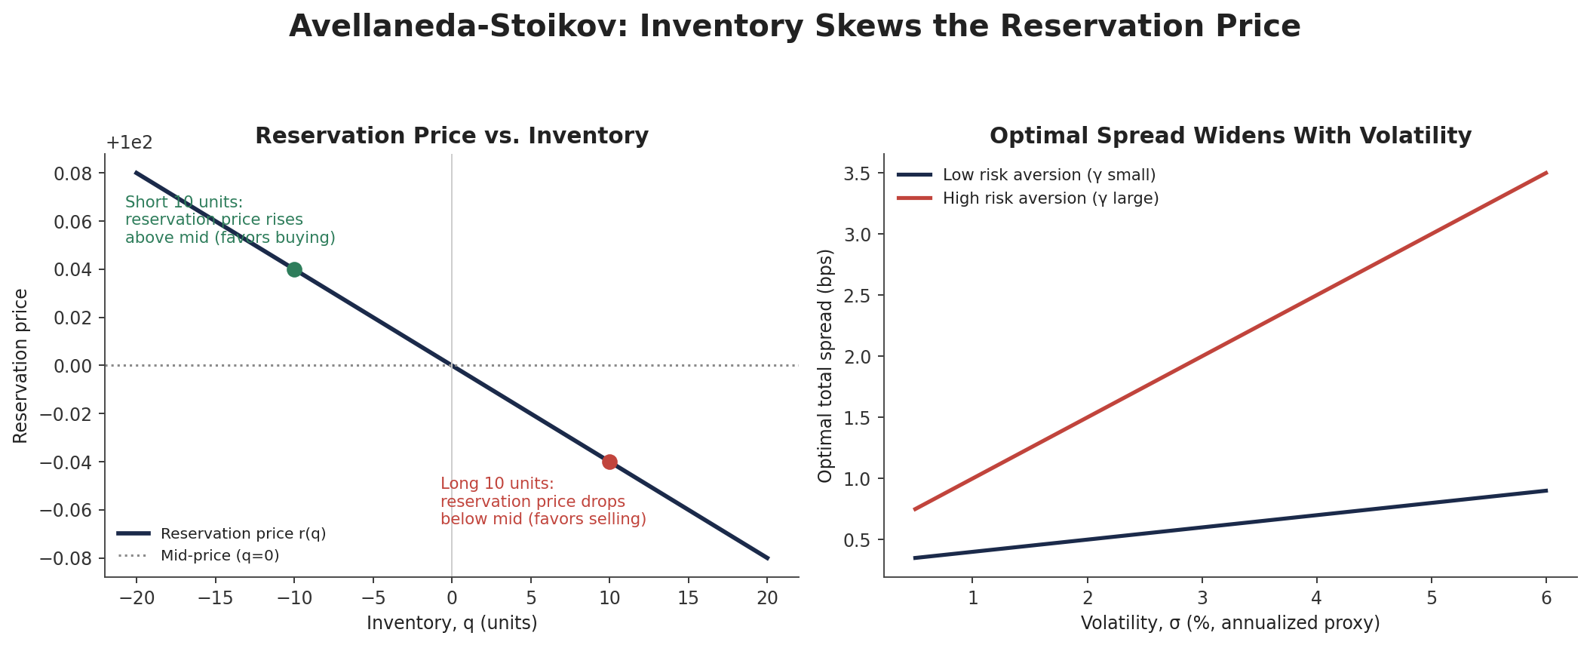
Figure 2.1 — The reservation price shifts linearly away from mid as inventory builds (left), automatically leaning quotes toward flattening the position. The optimal total spread around that price widens with volatility and with risk aversion (right).

2.3 The Avellaneda-Stoikov Model
Avellaneda and Stoikov (2008) formalized this intuition as a stochastic optimal control problem: maximize expected utility of terminal wealth, where the market maker chooses bid and ask quotes continuously, inventory evolves from random fills, and the mid-price follows a Brownian motion. The solution yields both the reservation price above and an optimal total spread:
δ_total = γσ²(T−t) + (2/γ)·ln(1 + γ/k)
where k parameterizes how quickly fill intensity decays with distance from the mid-price (Part 4). Quotes are then placed symmetrically around r(s,q,t), half the total spread on each side: bid = r − δ_total/2, ask = r + δ_total/2. The model's central insight is that optimal quoting is never symmetric around the mid-price once inventory is nonzero — it is symmetric around a reservation price that itself moves with inventory, risk aversion, and time remaining.
import numpy as np

def as_quotes(mid, inventory, gamma, sigma2, time_left, k):
r = mid - inventory * gamma * sigma2 * time_left # reservation price
total_spread = gamma*sigma2*time_left + (2/gamma)*np.log(1 + gamma/k)
bid = r - total_spread/2
ask = r + total_spread/2
return bid, ask, r

# a market maker long 10 units, moderate risk aversion, quotes tighter/lower
# than one who is flat -- exactly the inventory-skew intuition of Section 2.2
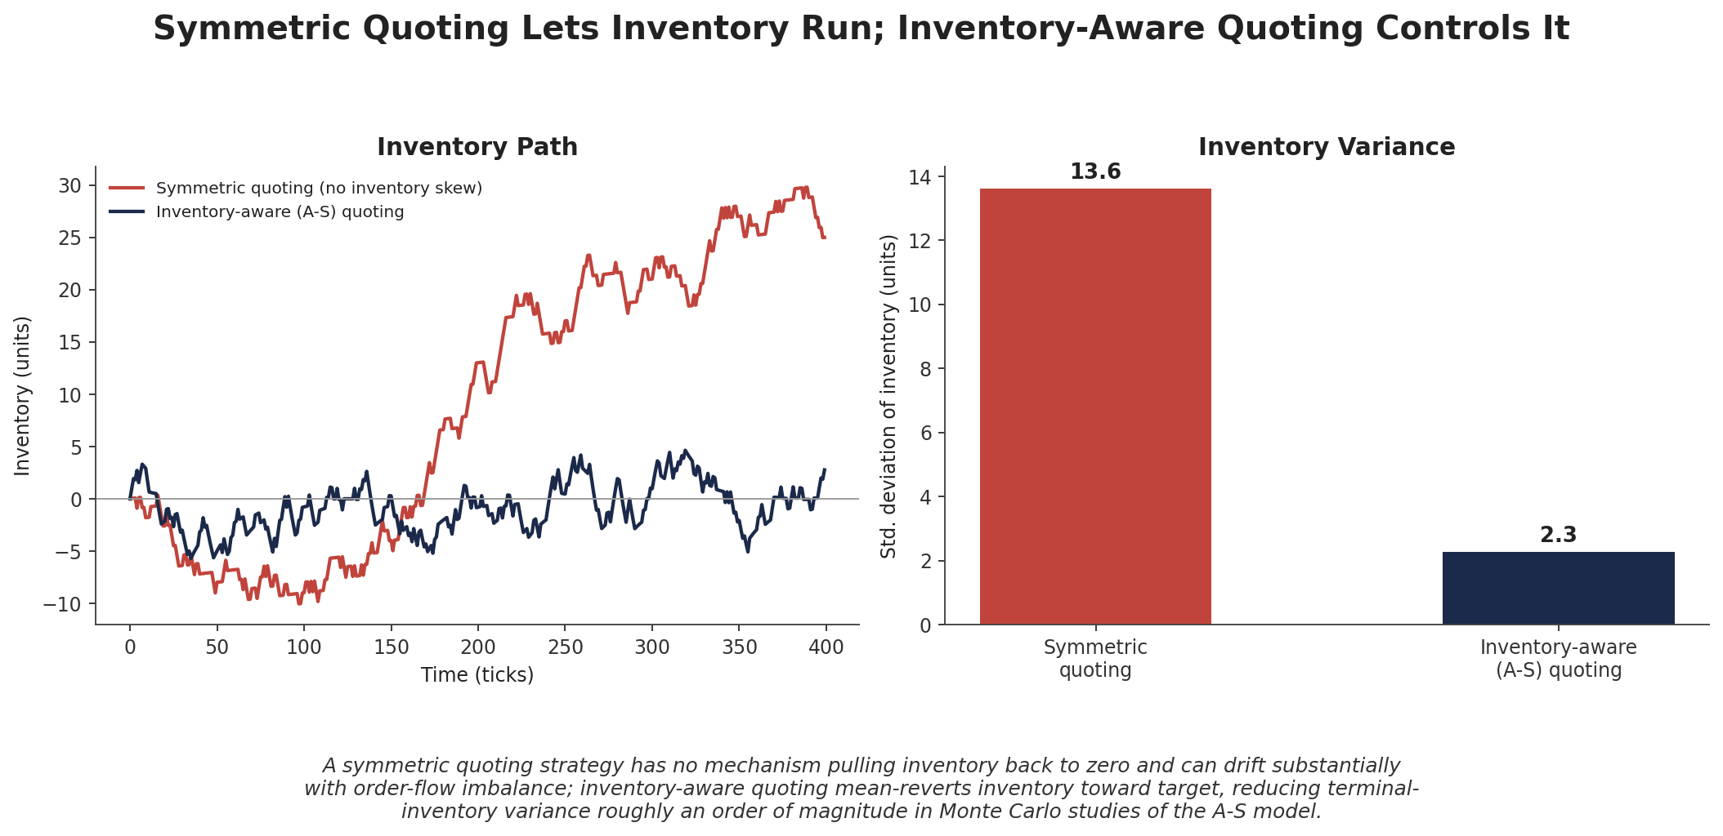
Figure 2.2 — Symmetric quoting has no mechanism pulling inventory to zero and drifts substantially; A-S quoting mean-reverts inventory toward target, reducing terminal inventory variance by roughly an order of magnitude in Monte Carlo studies of the model.
Worked example — quoting a single name
Mid-price s = $100.00, inventory q = +8 units (long), risk aversion γ = 0.1, volatility σ = 2% per period (σ² = 0.0004), time remaining (T−t) = 5 periods, fill-decay parameter k = 1.5. Reservation price: r = 100 − 8×0.1×0.0004×5 = $99.9984. Optimal total spread: δ = 0.1×0.0004×5 + (2/0.1)×ln(1+0.1/1.5) ≈ 0.0002 + 1.291 ≈ 1.291. Quotes: bid ≈ 99.353, ask ≈ 100.644 — both shifted down from a naive $99.35/$100.65 symmetric quote by the same 0.0016 reservation-price offset, making the ask relatively more attractive and the bid relatively less attractive, nudging the book back toward flat.

Two things are worth noting in this example. First, the reservation-price shift ($0.0016) is tiny relative to the spread itself (~$1.29) at this modest inventory level and short horizon — inventory skew is a second-order correction, not a wholesale repricing, which is exactly why naive strategies that ignore it can survive for a while before the effect compounds into real risk. Second, both γ and (T−t) entered the spread multiplicatively: doubling either the risk-aversion parameter or the remaining time horizon widens the inventory-driven component of the spread proportionally, which is why spreads are typically widened deliberately into a session's close, when unwinding inventory becomes harder and (T−t) conceptually approaches an effective boundary.

Part 3 — Adverse Selection

3.1 Being Filled for the Wrong Reason
A resting limit order is a free option: anyone can trade against it, and they will disproportionately do so when it is favorable to them — meaning the market maker's quote was stale relative to information the counterparty already had. This is adverse selection, and it is structurally unavoidable rather than an execution flaw: the market maker is, by construction, always the last to know.
Common beginner mistake —
Ignoring adverse selection — being filled disproportionately just before adverse price moves. A strategy validated only on gross spread capture, without separately measuring the P&L drag specifically attributable to fills, will systematically overstate expected profitability.

3.2 Measuring Order-Flow Toxicity
Order-flow toxicity measures such as VPIN (Volume-Synchronized Probability of Informed Trading) estimate, from recent buy/sell volume imbalance, how likely it is that current flow is dominated by informed participants rather than noise traders. VPIN buckets trading activity by volume rather than clock time, then averages the absolute imbalance between buyer- and seller-initiated volume across buckets:
VPIN = ( Σ |V_buy,i − V_sell,i| ) / ( n · V_bucket )
where each of the n buckets contains a fixed volume V_bucket, classified into buy- and sell-initiated volume (commonly via the bulk-volume classification technique). Empirically, spikes in such toxicity measures tend to precede adverse mid-price moves, and fills captured during high-toxicity windows realise systematically worse P&L than fills captured when flow looks balanced — the direct empirical signature of adverse selection a market maker needs to price into its spread.
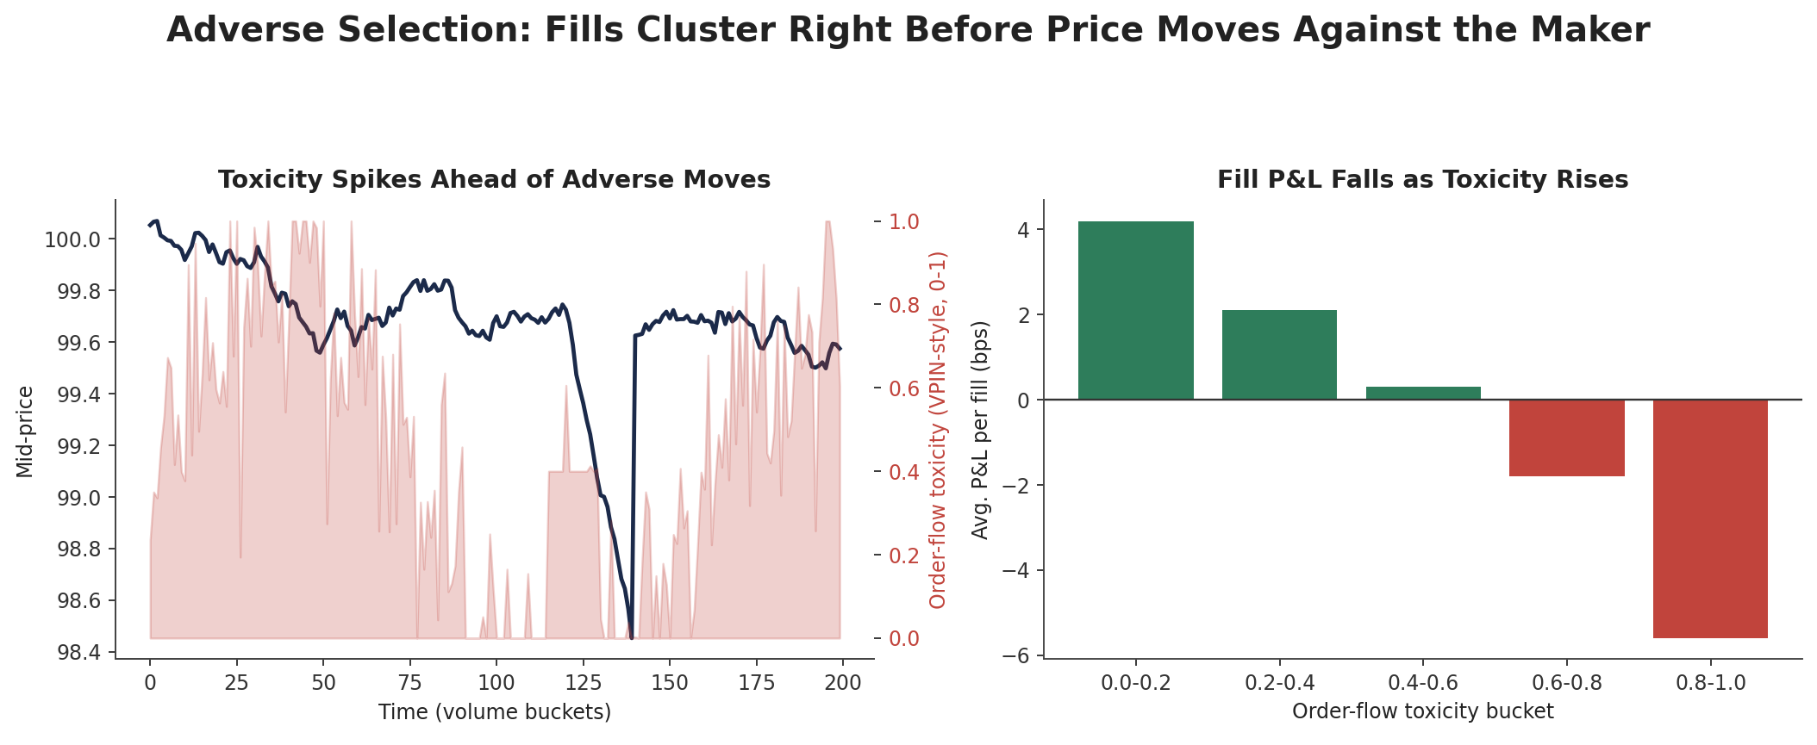
Figure 3.1 — A VPIN-style toxicity measure rises ahead of adverse mid-price moves (left); fills realised during high-toxicity windows show systematically worse average P&L (right).

3.3 Order-Book Imbalance and Short-Term Prediction
A closely related, more directly actionable signal is order-book imbalance — the normalized difference between resting bid and ask volume at the top of book. Academic microstructure research finds this imbalance is one of the most robust short-horizon predictors of the next mid-price move: a bid-heavy book tends to precede upward moves, an ask-heavy book downward moves. A market maker's quoting logic uses the same imbalance to lean its reservation price defensively, ahead of — rather than only in reaction to — the price move that imbalance tends to predict.
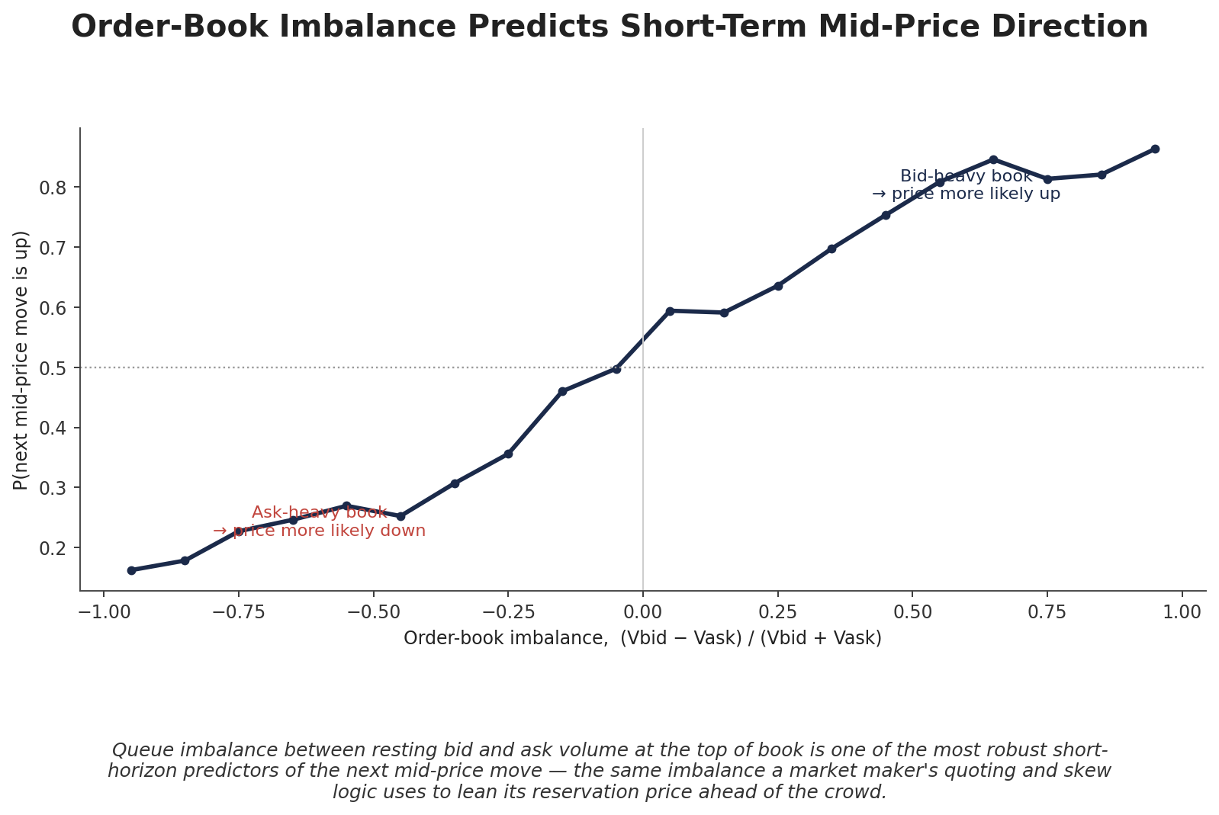
Figure 3.2 — Order-book imbalance is a strong, monotonic short-horizon predictor of mid-price direction, well documented in the queue-reactive and imbalance-forecasting microstructure literature.

Part 4 — Queue Position and Fill Probability

4.1 Why Queue Position Is a First-Class Variable
Two resting orders at the identical price can have very different fill probabilities purely based on queue priority (typically FIFO by arrival time at a given price level). Academic queue-position research shows fill probability and expected time-to-fill depend materially on where in the queue an order sits, independent of price — and that adverse selection itself interacts with queue position: orders that sit deeper in the queue tend to execute against larger, more informed counter-flow (since only a big enough order reaches deep into the queue), so on average they should be sized smaller precisely because they are more exposed to adverse selection, not less.

4.2 Modelling Fill Probability
The standard simplification, used in the original Avellaneda-Stoikov paper and widely adopted since, models fill intensity as decaying exponentially with distance δ from the best quote:
λ(δ) = A · e^(−kδ)
This reduced-form assumption is mathematically convenient — it is exactly the k that appears in the A-S optimal spread formula (Section 2.3) — but does not explicitly capture queue-position or time-of-day effects. More recent research models the order book as a birth-death queueing process, deriving fill probabilities and time-to-fill as first-passage times, and separately documents that fill probabilities are highest (and fill times fastest) near the market open and close, and slowest around midday — a pattern that persists across time horizons and is directly relevant to how aggressively a market maker should quote at different times of the trading day.
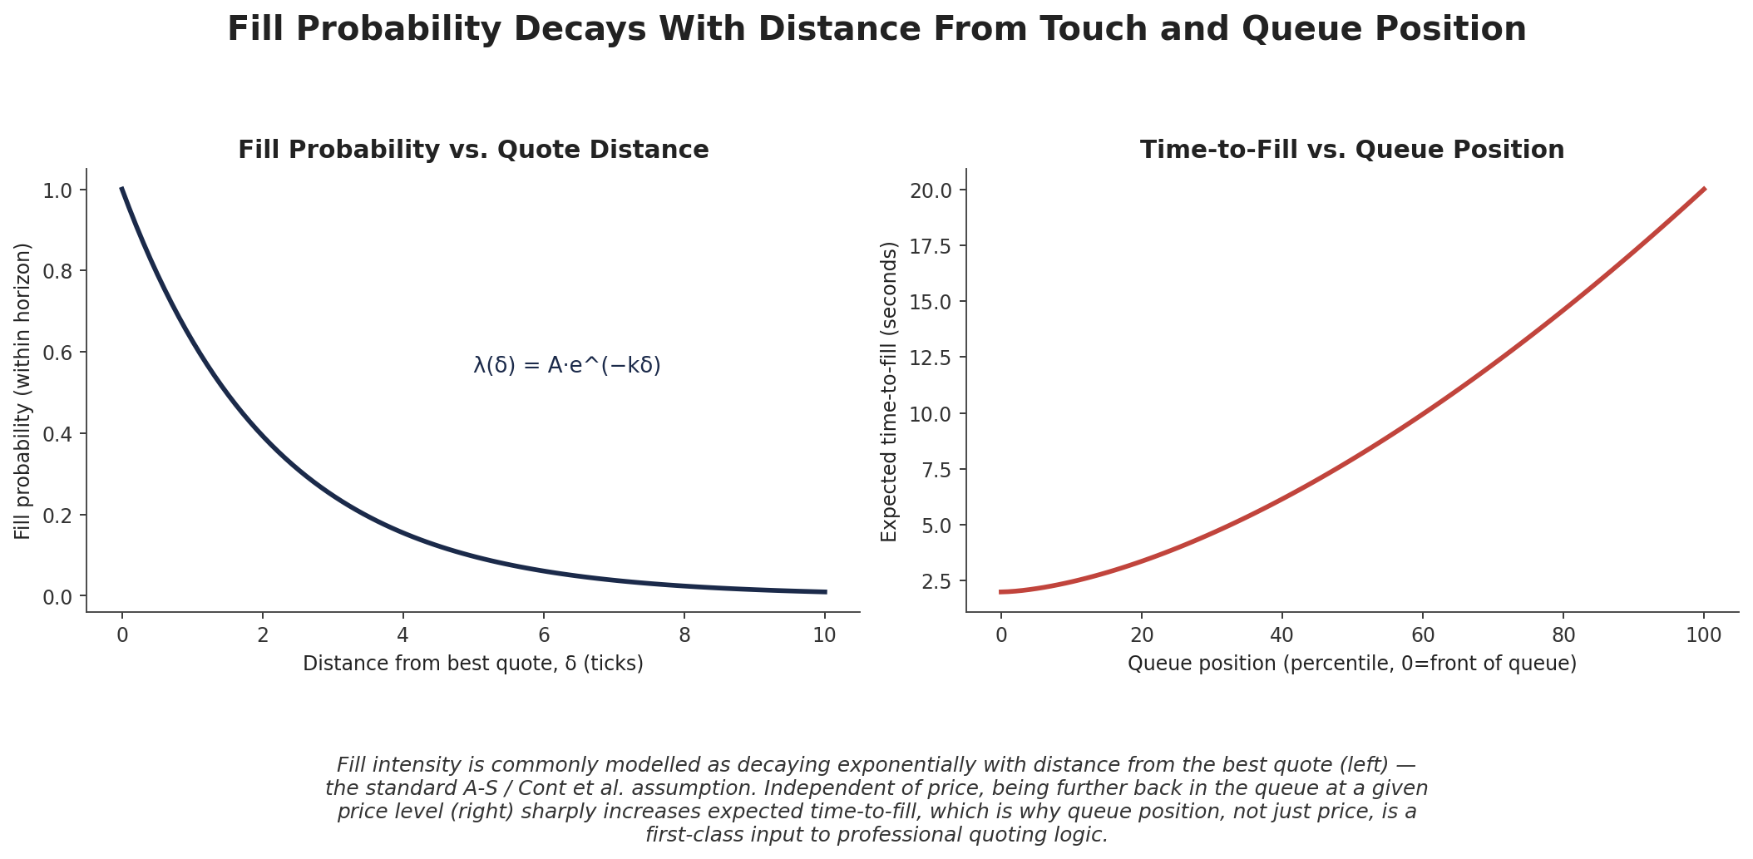
Figure 4.1 — Fill probability decays exponentially with distance from the best quote (left, the standard A-S/Cont et al. assumption); independent of price, deeper queue position sharply increases expected time-to-fill (right).

Part 5 — Dynamic Spreads, Hedging & Cross-Venue Market Making

5.1 Dynamic Spread Rules
Combining Parts 2–4, a production quoting system ties spread width directly to real-time conditions rather than quoting a static spread: widening automatically as realised volatility rises (directly, via the A-S formula's σ² term), as order-flow toxicity rises (Section 3.2), or as inventory moves further from target (via the reservation-price skew). This removes the need for manual intervention during volatility events, at precisely the moments when a static spread would otherwise be badly miscalibrated.
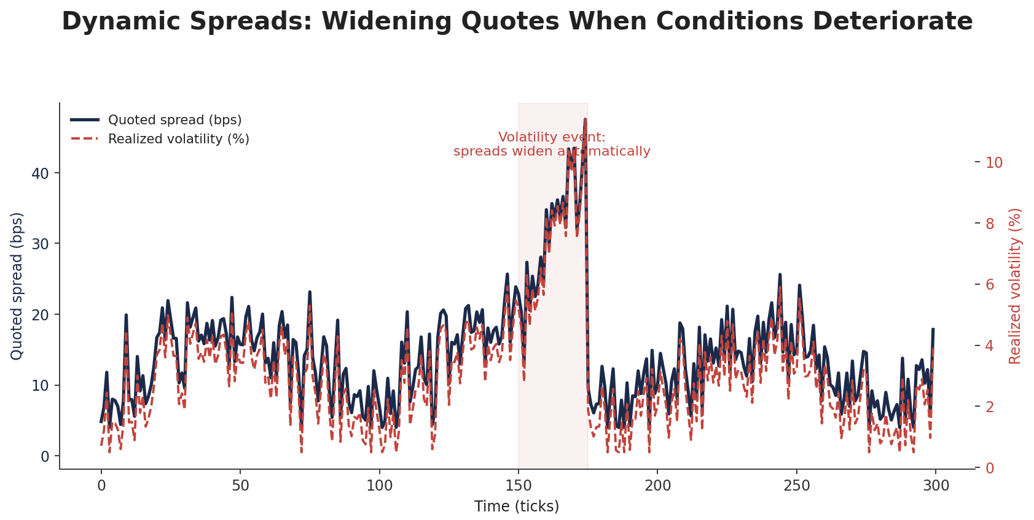
Figure 5.1 — A dynamic spread rule widens automatically as realised volatility rises, rather than requiring manual recalibration during a volatility event.

5.2 Hedging Residual Inventory
Even with inventory-aware quoting, some residual position typically remains, especially near the end of a trading session or ahead of a known event. Rather than aggressively crossing the spread to flatten it (paying away exactly the spread the strategy exists to capture), residual inventory is often hedged with a correlated, more liquid instrument — an equity market maker hedging single-stock inventory with an index future, or an options market maker delta-hedging with the underlying — converting inventory risk into a smaller, more manageable basis risk.

5.3 Cross-Venue and Multi-Asset Market Making
A market maker quoting the same or highly correlated instruments across several venues (e.g. the same asset on multiple exchanges, or a spot/perpetual pair in crypto) accumulates inventory independently on each. Netting that inventory centrally, then hedging the combined net exposure with a single instrument, is materially more capital- and cost-efficient than hedging venue by venue — and requires the correlated-inventory tracking called out explicitly as this module's advanced extension.
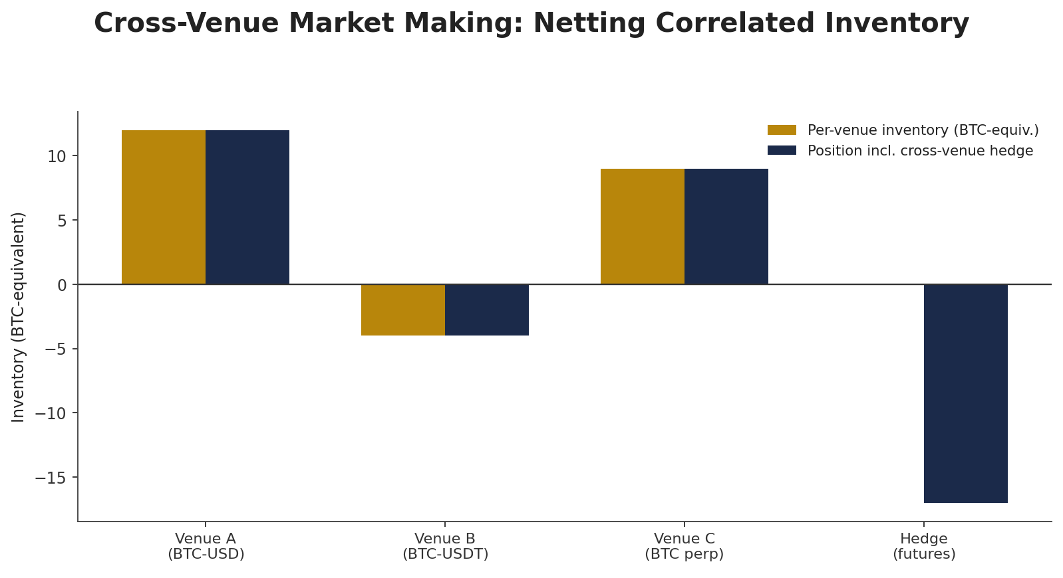
Figure 5.2 — Inventory accumulated independently across venues is netted centrally and hedged with a single instrument, rather than hedged venue by venue.

Part 6 — Options Market Making: Greeks-Based Risk
Everything in Parts 2–5 applies directly to options market making, with one structural addition: an options quote carries exposure not just to the underlying's price (delta) but to the rate of change of that exposure (gamma), to volatility itself (vega), and to time decay (theta) — a substantially richer risk surface than a single-instrument spot or futures book.

6.1 Delta-Hedging as Continuous Inventory Management
An options market maker's net delta — the sum of each filled option's delta, weighted by size — plays exactly the role that raw inventory q plays in Part 2's A-S framework: it is the directional exposure the reservation-price mechanism exists to control. In practice, options desks typically supplement inventory-aware quoting with continuous delta-hedging in the underlying itself, since the underlying is usually far more liquid than any single option strike and can absorb hedging flow with less market impact.
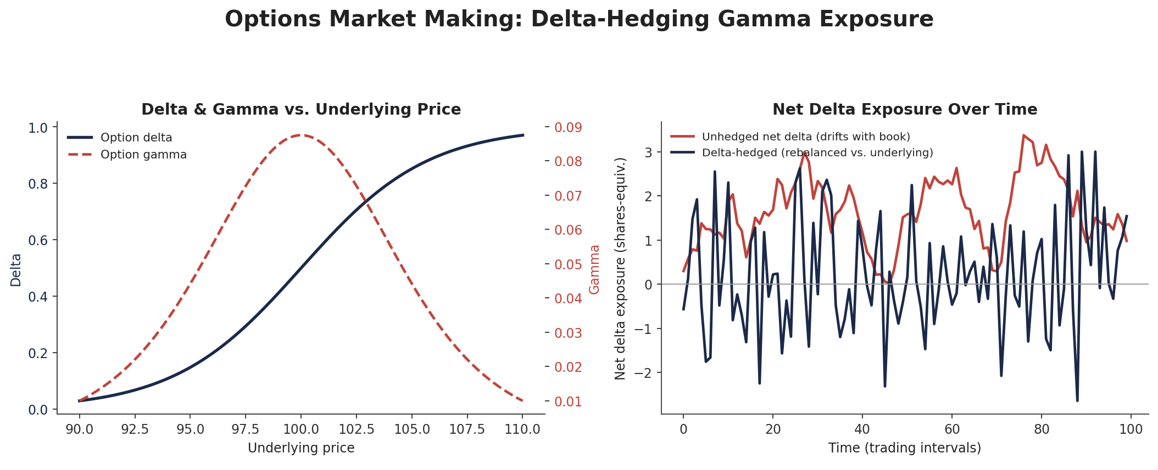
Figure 6.1 — Delta and gamma both peak near the strike (left); continuously hedging net delta with the underlying (right, navy) keeps directional exposure near zero, leaving gamma, vega, and theta as the book's primary residual risks.

6.2 Gamma and Vega as the Residual Risk
Once delta is hedged away, gamma becomes the dominant remaining risk: a large negative gamma position (typical of a market maker who has sold options net) loses money on large moves in either direction, since the hedge constantly lags the option's actual delta as the underlying moves — the hedging analogue of adverse selection, where large realised moves are disproportionately costly to a short-gamma book. Vega exposure — sensitivity to changes in implied volatility itself, independent of the underlying's realised path — is managed separately, typically by balancing the option book's net vega across strikes and expiries rather than hedging it with the underlying at all, since the underlying carries no vega exposure to offset against.
Risk factor | Hedged with | Analogous Part 2–3 concept
Delta (direction) | Underlying (continuous rebalancing) | Inventory q in the A-S reservation price
Gamma (convexity) | Other options; wider quotes near strike | Inventory risk cost, amplified near-the-money
Vega (volatility level) | Other options across strikes/expiries | No direct spot-market analogue
Theta (time decay) | Not hedged — priced into the quoted premium | Analogous to the (T−t) term in the A-S spread

Practical Exercise
Implement a simplified Avellaneda-Stoikov quoting model in a simulated limit order book and evaluate its spread-capture P&L versus inventory risk.
- Step 1 — Build a simple simulated order book: a mid-price following geometric Brownian motion, with order arrivals whose fill probability decays exponentially with distance from the best quote (Section 4.2).
- Step 2 — Implement the A-S reservation price and optimal spread formulas from Section 2.3, and generate bid/ask quotes at each time step based on current inventory.
- Step 3 — Run the simulation and separately track gross spread-capture P&L, ending inventory risk (mark-to-market P&L from any residual position), and realised inventory variance over the path (Section 2.2's diagnostic).
- Step 4 — Compare against a naive symmetric-quoting benchmark with the same total spread but no inventory skew — the A-S strategy should show materially lower inventory variance for comparable or better net P&L, directly demonstrating Figure 2.2's result.

Common Beginner Mistakes
- Quoting symmetric spreads regardless of inventory, allowing inventory risk to accumulate unmanaged (Section 2.1) — the fix is inventory-aware skewing via the reservation price, not a wider static spread.
- Ignoring adverse selection — being filled disproportionately just before adverse price moves (Section 3.1) — which requires directly measuring fill-conditional P&L, not just gross spread capture.

Advanced Extensions
- Cross-venue and multi-asset market making with correlated inventory hedging (Section 5.3) — extending single-instrument A-S quoting to a book quoting many correlated instruments simultaneously, with inventory netted and hedged jointly rather than independently.

Professional Applications
- Electronic market-making desks — the institutional home of the quoting, inventory, and hedging machinery covered in this module, running across equities, options, futures, and fixed income.
- Crypto market-making firms — applying the same A-S and adverse-selection framework to crypto spot and perpetual futures markets, often across many venues simultaneously (Section 5.3), given crypto's fragmented, 24/7 market structure.

Where to Go Next
This module derived the core theoretical machinery of market making — the reservation price, the Avellaneda-Stoikov spread, adverse selection, and fill-probability modelling — as a distinct discipline from directional alpha research. From here, further Trading-track material covers the live operational discipline of running a market-making book (risk limits, kill switches, real-time inventory dashboards), while further Research-track material extends the adverse-selection and queue-position models introduced here into the full cross-venue, multi-asset extension named above.

